GLOBAL MONEY WEEK MARCH 9-17
2015
Report by: Sukirti Rana
CWIN Nepal

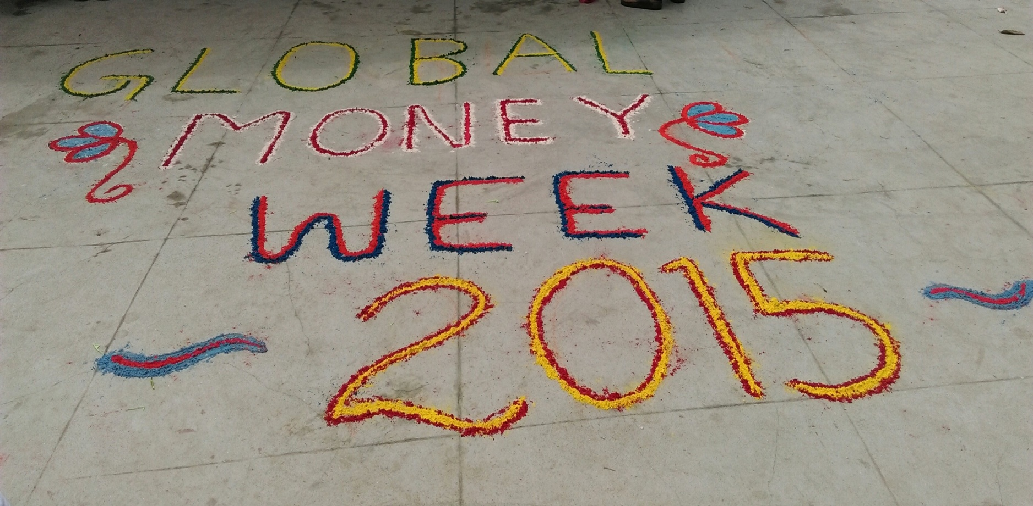
CELEBRATION OF GLOBAL MONEY WEEK

Every year, during the second week of March, young people around the world talk, play, create, sing, read, discuss and learn about saving, money, changing economic systems and building a financial future. Global Money Week (GMW) is celebrated annually between March 9-17 globally over 100 countries to raise awareness about how money works, including saving, creating livelihoods, gaining employment, entrepreneurship and engaging children and youth by giving them the tools, skills and inspiration they need to shape their own future with proper financial education.
This year GMW was celebrated worldwide with the global theme ‘Save today. Safe tomorrow’.

Child Workers in Nepal Concerned Center (CWIN Nepal) has been celebrating Global Money Week since 2012 and even this year it celebrated Global Money Week on 10-16 March 2015 by organizing different programs focusing on training, rally, interaction programs along with meaningful participation in the workshops and rally organized by Nepal Rastriya Bank. The Week brings the world one step closer to ensuring that every child will have access to financial services, financial awareness through education, a reliable source of income, and the will to save.

CWIN Nepal organized following programs to mark the celebration of GMW 2015. The program schedule for Celebrating Global Money Week was as following:
Date | Activity
10 March 2015 | Documentary show
13 and 15 March 2015 | Orientation on Social and Financial Education to Street Children and street field workers
13 and 15 March 2015 | Orientation on Social and Financial Education to another group of street children and Street Field workers
14 March 2015 | Participate in rally organized by Nepal Rastriya Bank
16 March 2015 | Interaction with Youth and stakeholders on Role of key stakeholders in ensuring access of young people in financial literacy and services
17 March 2015 | Participate in workshop organized by Nepal Rastriya Bank

Orientation on social and financial education for street children and street field workers
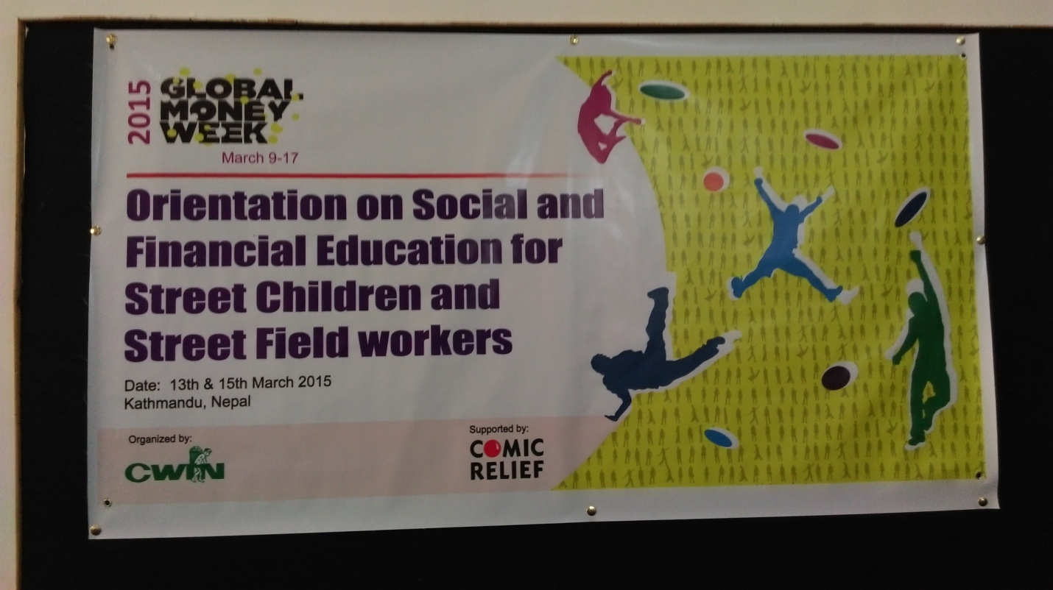Venue: Hotel Orchid
Date: March 13 and March 15, 2015
Organized by: CWIN-Nepal
Supported By: Comic Relief
Introduction
An orientation program on "Social and Financial Education for Street Children and Street Field Workers" organized by CWIN Nepal to celebrate Global Money Week was held on March 13 and 15 2015 at Hotel Orchid in the capital. The program was focused on providing social skills and education about how money works for a safe tomorrow with proper saving and spending habits in children and youth living in the streets for their better future.
The orientation program on March 13 and 15 was divided into two parts with the first session focused on street children and the second session focused on Training of Trainers (TOT) to the street field workers and peer educators.
The orientation program was facilitated by Mr. Sagar Raj Pradhan, Program Officer at CWIN Nepal.
On March 13 2015, a total of 38 street children and street field workers participated in the program. Of them 18 (17 boys and 1 girl) were street children from New Road, Jamal, Bagbazaar, Mahankal, Durbarmarg, and Teku and 20 were streets field workers/ peer educators of Child Watabaran Center Nepal, Child Protection Center and Services, Khushi Nepal, APC Nepal, Big Umbrella, Shelter Home.
The age groups of street children participating on March 13 are as following:
Age Group | Male | Female
15-18 years | 6 | 0
19-24 years | 8 | 1
25 years and above | 3 | 0
Total | 17 | 1

On March 15 2015, a total of a total of 59 street children and street field workers participated in the program. Of them 41 (32 boys and 9 girls) were street children from Pashupati, Setopul, Sinamangal, Old Baneshwor, Mahankal ,Banshighat, Teku, Tripureshwor, Kupundole, Kalanki and Kirtipur and 18 were streets field workers/ peer educators of Child Watabaran Center Nepal, Child Protection Center and Services, Khushi Nepal, APC Nepal, Big Umbrella, Shelter Home.
The age groups of street children participating on March 15 are as following:
Age Group | Male | Female
5-12 years | 13 | 2
13-18 years | 14 | 4
19-27 years | 5 | 3
Total | 32 | 9

Objective of the program
The training focused on providing 'Aflateen' training tools to help children and youth learn about finance and encourage them to question world around them. To help them learn by being involved in interactive fun filled activities to make the learning fun and practical so that the learning lasts throughout their life. The objectives of the program also revolved around the following points:
- To empower the children living in streets to be confident, responsible and skilled economic citizens
- To encourage youth and children to share their ideas and elevate these ideas and motivate towards saving smartly
- To teach street children about saving money and provide them with social skills and financial education
- To orient street field workers to better orient the street children about the saving and spending habits
- To orient street field workers on designing social, financial and hybrid enterprises and better understand the concept of enterprise.
Program Detail (March 13 2015)

First session with street children (March 13 2015)
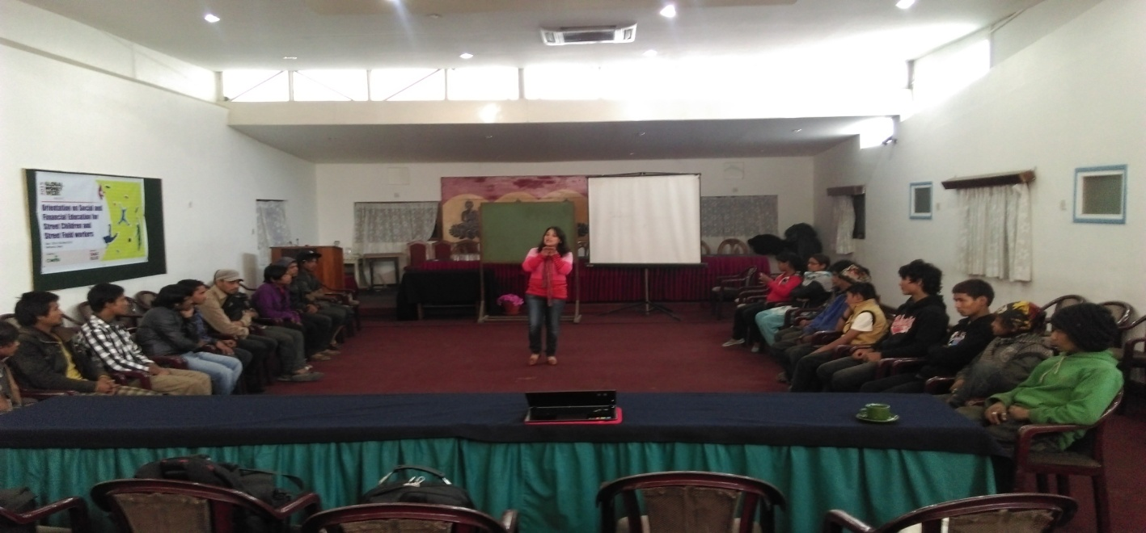
On March 13, Ms. Sumnima Tuladhar, Executive Coordinator of CWIN Nepal shared her experience of childhood when she used to spend her money unwisely. She shared that she regretted it later when she used to be sort of money at the time of real need. She asked the street children where they spend their money and urged them to analyze if their hard earned money was being used wisely.
Street children responded that they have been spending their money in food, medicine, clothes, cigarette, alcohol, and drugs. Only some children admitted of saving some money for their family and future.
She introduced herself to the street children as their friend and introduced about CWIN to be the pioneer organization to work with street children and how it has been working with children like them to make their future better in every way possible.
She encouraged the children to visit their family if not permanently decide to live with them and that CWIN would help them visit their family or provide any kind of support for their family reunion, medical support or any other emergency support. She encouraged the children to voice their concern about future and what skills/training they would want to take up to help them get a secure marking their interest.
She advised them to save their money and not spend them unwisely in cigarette, drugs, alcohol or gambling. She said that, "One should develop the habit of saving money. I never learnt saving but now I have realized that it is very important to save. Saving habit is a step useful throughout the life."
Mr. Sagar Raj Pradhan started the orientation with an ice breaking activity. The name of the game was Frozen Picture/Image theatre. Some of the participants were asked to freeze in a given situation no sound and no mobility. The rest of the participants were then asked to express what they perceived the frozen picture as. The objective behind this activity was to let them know their potentiality of molding them in any given situation. Each individual posses some or the other kind of potential inherent in them, they just need to analyze and critically think about their potentiality. Only after looking at ones potential can the person know for his/her weakness and strengths, set goal and work towards achieving it for which financial aspect will always play an integral part. This activity also helped the children to learn about saving management and focus on importance of becoming a responsible spender and saver.
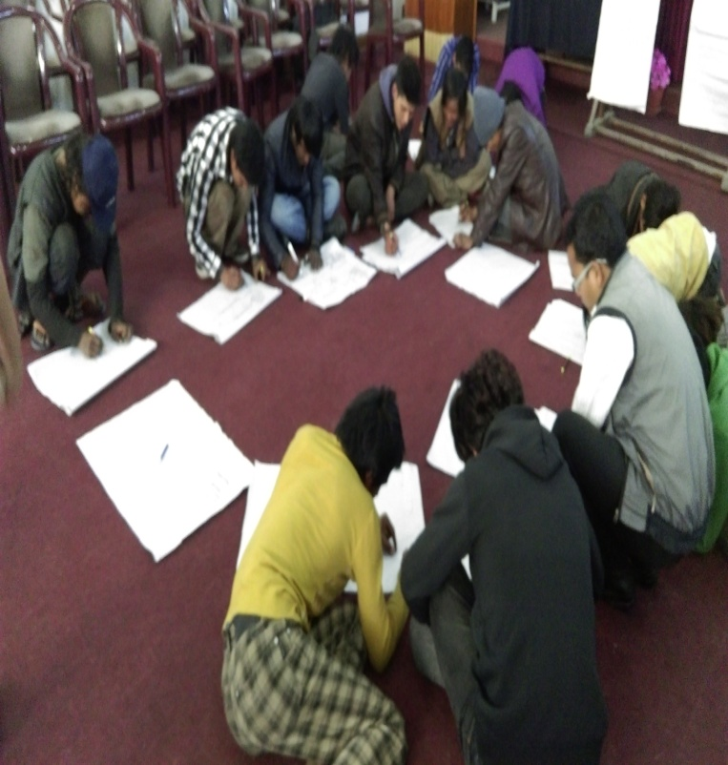
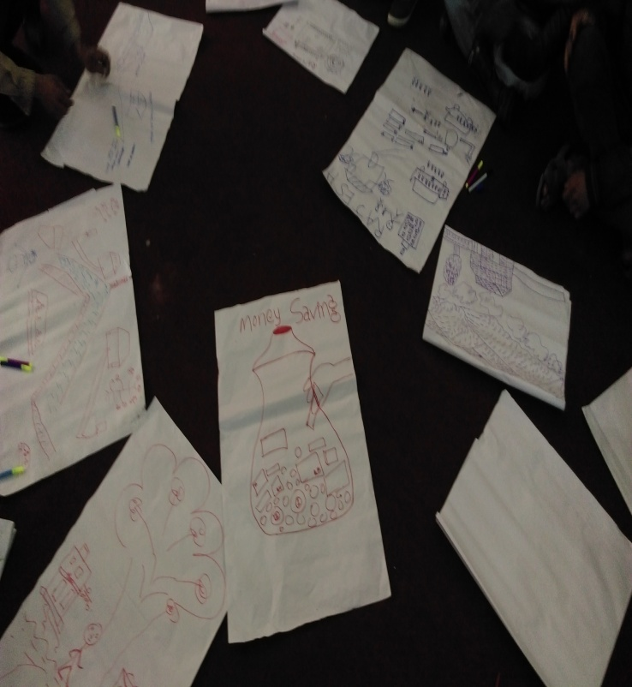
After this activity, children were asked to draw about what they think of saving and money. Children drew money, bank and many more. They let their creativity burst in the form of drawing and it could be seen their creativity and imagination had no limits and boundaries.
After the drawing activity children were provided with some refreshments after which Mr. Pradhan oriented them about the following:
- Different between Dream and Goal
- Personal understanding and exploration
- Difference between Need and Wants
- Important of personal budgeting and planning
- Saving of resources and reuse
The street children were asked to ponder over the requirements for their survival. They felt happiness, job, and regular work to bring money as the main requirements.
They were asked about their dream and goals. He explained the difference between them and helped them to learn to explore their own identity. Dreams acts as motivation and a burning light to inspire to achieve the goal. Goals when set helps to make the dream to become a reality. It stretches and enhances skills, abilities and can be a change agent for the life when taken seriously.
They were asked of things that would help their life become easier. Children said that jobs after receiving trainings (cooking, singing, driving, mechanics, masonry, welding, etc) would help their life become easier. For this they were advised to link these with the habit of saving and spending their time wisely to take right decision. He said that responsible saving done when saving is done with happiness, satisfaction and good habits.
He said that they could save their money in piggy banks (khutruke), finance companies, cooperatives, banks etc.
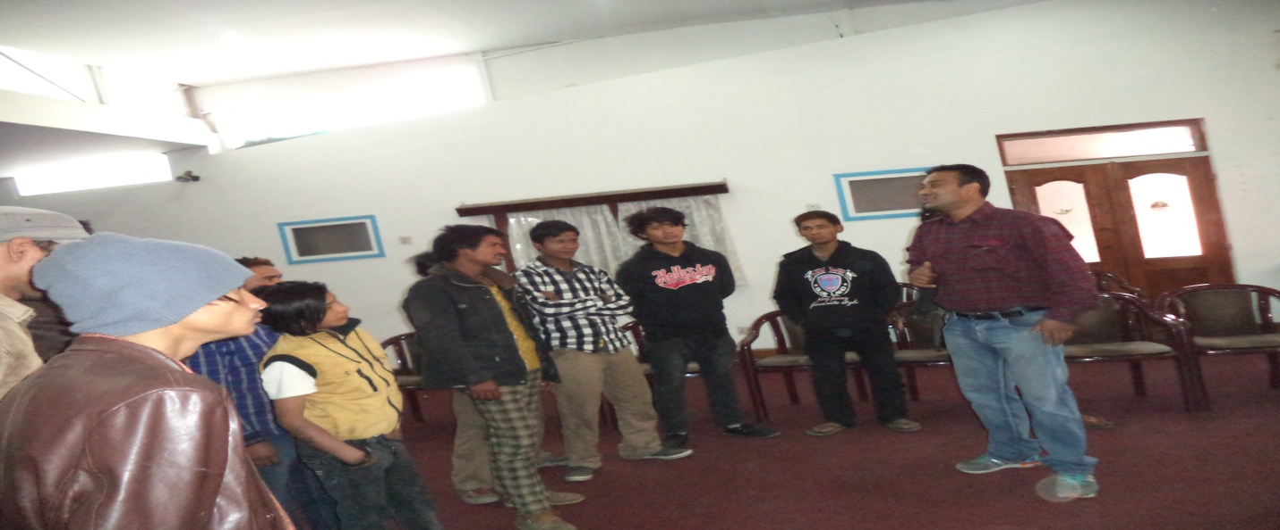
He further said that there is a bigger difference between needs and wants. Need is a necessity but wants is a desire after the fulfillment of basic necessities. Needs might be spending money for clothes to cover the body, buying foods and medicines etc but want can be anything from spending lavishly on clothes, drinking alcohols, buying drugs, etc,
He said that analyzing the weakness is the first step towards improving them. He also shared about the value of one's life, perception on life that will drive the life towards right or wrong direction, the will to change and the potential to change. He encouraged the children to love their life and use their time and money wisely with proper planning, happiness, satisfaction, and good habit.
He also advised the street children to know that there are organizations working for street children. They should know about the training they need, where their interest lies in, where their strength lies. He said that strength is not only about the physical strength but the self confidence and determination to achieve the goal set for life.

Second session with peer educators, field workers of organizations working with street children
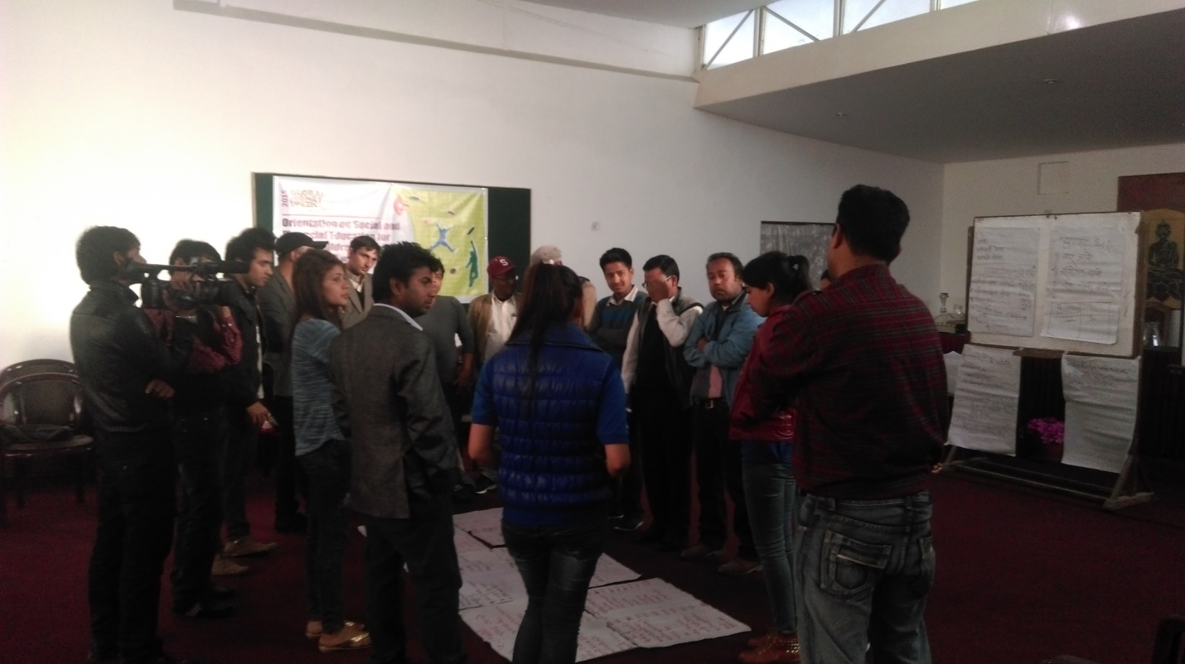
The second session facilitated by Mr. Pradhan focused on providing TOT to the street field workers/peer educators to orient them about the skills for smart saving, building saving habits so that they can further teach them to street children and act as a facilitator later in future. The objectives the program scheduled on March 13 helped the participants to learn about:
- Exploration of one’s Strength and Weaknesses in Achieving Goals
- Different between Dream and Goal
- Difference between Need and Wants
- Four Pillars of Child Rights (Focus on how to become responsible spender / saver )
- Saving of resources and reuse
Mr. Pradhan introduced them about Aflatoun/Aflateen and the purpose of the training. The Aflateen program is a curriculum created by the Aflatoun secretariat that brings social and financial education to youth worldwide. Tailored specifically for this developmental phase, the Aflateen program not only teaches about finance but also encourages young people to question the world around them. They explore concepts such as age, gender, nationality, ethnicity, socio-economic status and religion. Aflateen’s mission is ‘to inspire socially- and economically- empowered young people to lead responsible lives and be agents of change. (http://aflateen.org/about/)
After the brief introduction about the objectives and their roles henceforth after receiving the training, he divided the participants into two groups. Participants were asked to write their names, organizations and to draw 5 things that they used in the last 7 days and name of the song you like the most. After 5 minutes, each two participants shared what the other one drew and sang their favorite song. This activity was carried out as an ice breaking activity along with introducing new ways of introduction when conducting trainings or programs.
After this activity, participants participated in drama where they were asked to act in a given situation. Two groups showed two dramas with same situation but different approach. Drama involved a teacher and some students in a class setting where the teacher teaches about the child rights. In the first drama: teacher was not responsible and delivered his responsibility well but in another the teacher was fairly good at delivering information about child rights. Through this activity he wanted the participants to learn that it is the sole responsibility of trainer/facilitator how he delivers and conducts the program, to make the participants understand, become interactive and ensure the effectively of the program.
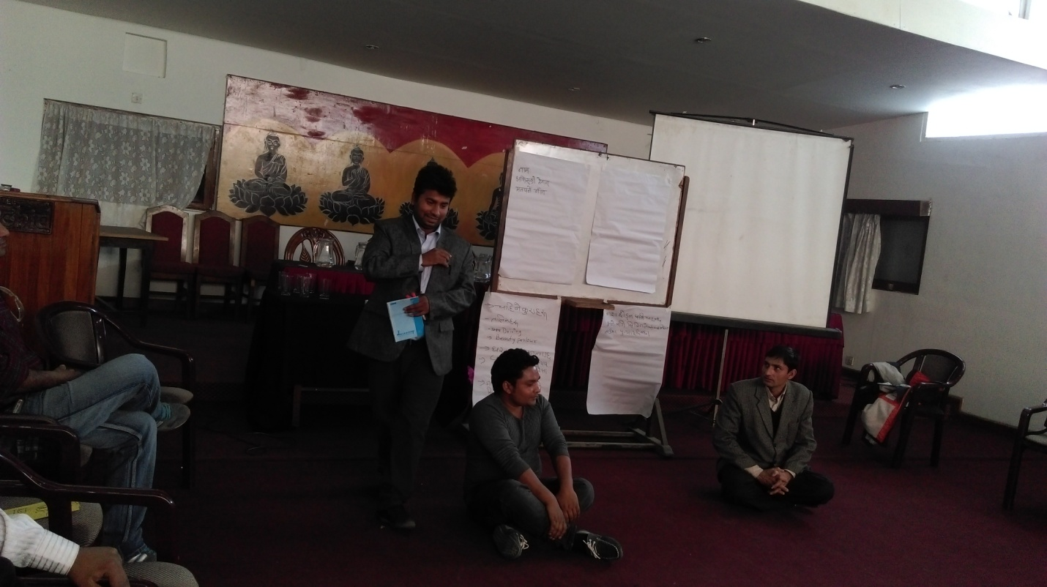
Like in the earlier session with street children, he conducted a session with street field workers about needs and wants, dreams and goals and linked all these with the essence of saving and spending habit. Mr. Pradhan guided them through the five core elements of the curriculum set for Aflatoun programs. They are:
- Personal Understanding and Exploration
- Rights and Responsibilities,
- Savings and Spending
- Planning and Budgeting
- Social and Financial Enterprise
Freeze picture/Image theatre activity was also carried out with street field workers as well. After this activity, participants were asked to write about the income and expenditure for three different age groups mainly below 12 years, 13-19 years and 19-25 years. Participants wrote about the possible income and expenditure of three age groups both for boys as well as girls. This helped the participants to learn that there are many sources of income for all the age groups and helped clear the preconception that children do not have money to save. This activity also helped them to list out things where the money is spent and to analyze if the money is spent on fulfilling the needs or wants. This also helped them to ponder over smart saving options and how they can save responsibly without hindering basic needs.

Program detail (March 15 2015)

First session with street children (March 15, 2015)
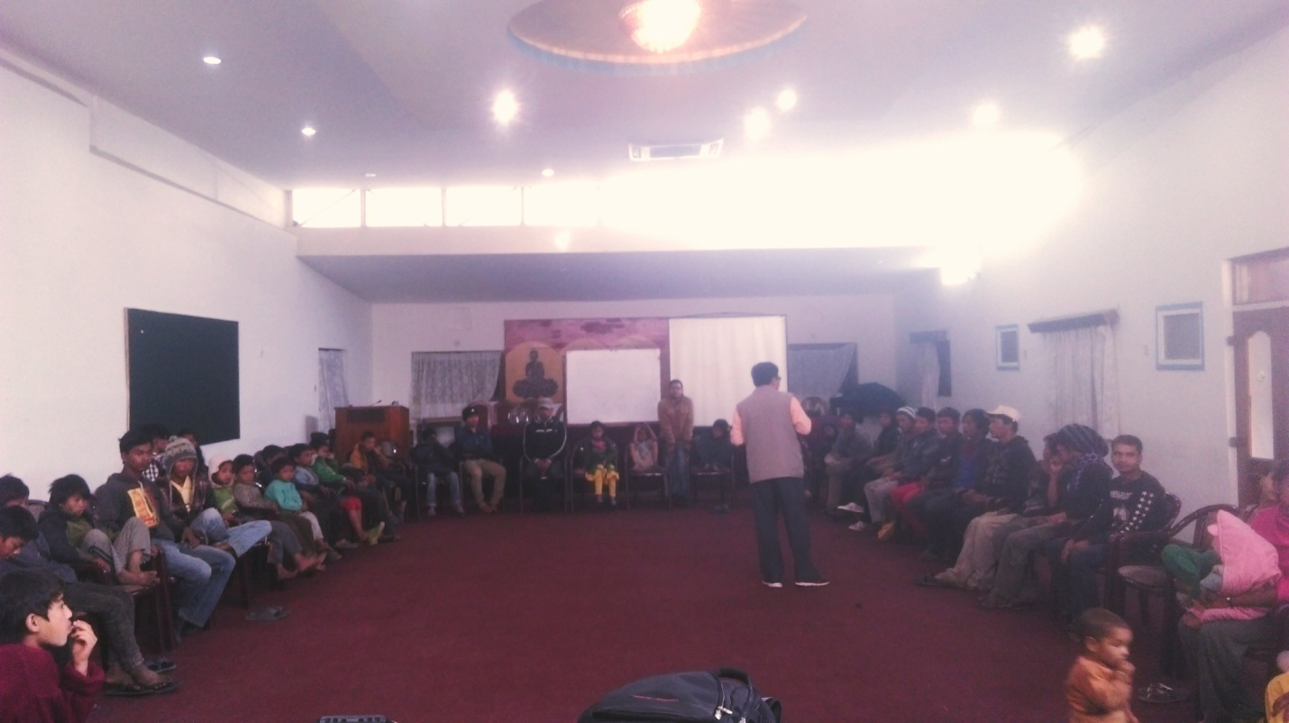
Mr. Madhav Pradhan, President of CWIN Nepal welcomed the street children in the orientation program and hold some informal talks with street children about their dreams, aspirations, interest and their take on life. He also asked them the value of money in their life.
Street children valued money but said that the money earned by petty thefts or begging is not much valued as compared to the money earned by earnest job. Sharing the history of CWIN-Nepal with street children decades ago, he tried to motivate street children of today to understand the importance of saving and how they could do it. He shared about Common Room of CWIN which was for the street children, a space to bring the children together for better life. CWIN-Nepal the pioneer organization working with street children always promoted the habit of saving and small investments through 'Kitchen Club', and 'Street Children Bank' where street children saved the money earned after making cards, small handicrafts which CWIN then sold and helped those children earn some money. Through these innovative approaches street children could save hundreds of rupee and use it for their education or family expense which otherwise could have been spent unwisely.
The first session held on March 15 was same like the ones carried out on March 13, 2015 holding the same objective. Since most of the street children participating on that day were children below 15 years, the facilitator tried to entertain children by involving them in dancing and singing and lots of refreshing, fun filled activities like drawing, acting etc.

Second session with peer educators, field workers of organizations working with street children
The second session held on March 15 2015 was the continuation of the training held on March 13 2015. On this session, participants were oriented on saving management including Importance of personal budgeting and planning management of saving in different financial institution. The session also focused on orienting about micro enterprises along with their different types.

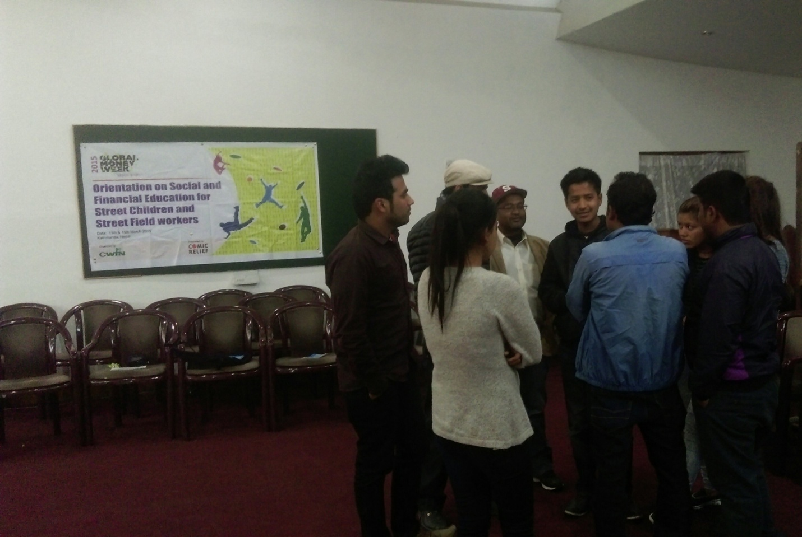The participants were asked to act on a topic provided to them by the facilitator. He asked all the four groups that had been divided with 4 participants each to perform a silent act on the topic "Recycle". Each showed their unique potential to act something on "Recycle". One of the objectives behind the silent drama was to help them better understand the importance of recycling with their and their peers act. Mr. Pradhan explained about the 6 R of saving that includes Reuse, Recycle, Reduce, Refuse, Rethink and Repair. He asked participants to provide examples of 6 R and what they understand about saving. After their response, which was fairly good, Mr. Pradhan helped them to link it with saving resources-saving money, saving time-saving money.

Mr. Pradhan also explained about the attributes of thoughtful and civilized saver with the help of an interactive game of "For and Against" to the given situation put forward to the participants.
He also made them play the "Snake game" by rolling the dice and helping them learn more of smart saving and spending.

Next, he moved on to the next component-Planning process and budgeting. He explained that Planning and budgeting helps children to set personal as well as financial goals. He introduced it as the skill that is essential for any development. Planning including financial planning is one of the crucial steps taken towards achieving a goal that has been set.

He then asked the participants to show a drama following the directions of the facilitator. This was done to show that it is in the hands of the facilitator to bring the best out of the participants.
It depends upon the delivery of the facilitator, how the participants will learn and also it is in the hands of participants to make the facilitator successful. This was carried out to help them understand the role of a facilitator and become a better facilitator for children they are working with.

In the end of the second session, he explained about three types of micro enterprise including Social enterprise, Financial enterprise and Mixed enterprise. He thoroughly guided participants in preparing a proposal for a 1 month project for all three enterprises (one enterprise by one group). All these three groups prepared a proposal with budget.
In the project proposal of their enterprise they mentioned the following:
- Name of the enterprise
- Name and place of the proposed business
- Objective of the proposed business
- Role and time delegation for activities to be carried out under the project
- Strength, Weakness, Opportunities and Threats (SWOT Analysis)
- Budget

Conclusion

The session ended with the reflection from the participants receiving the training/orientation. The participants felt that the program was very helpful, informative and practical along with the training materials being interactive and fun filled. They felt that the orientation helped them to better understand about smart saving and spending, planning and budgeting, micro enterprises, and the role of good facilitator. They also wished to participate in more of such trainings in future. Thus, CWIN Nepal successfully conducted orientation cum training based on Aflatoun/Aflateen to street children and street field workers/ peer educators to help them become financially responsible citizens and help shape their future in a better with social and financial education.

